TRADE OF
Pipefitting

PHASE 2

Module 3

Pipe Processes

UNIT: 3

Bill of Materials

Produced by

In cooperation with subject matter expert:

Finbar Smith

© SOLAS 2014
Table of Contents
Unit Objective 1
Learning Outcome 2
1.0 Introduction to Bill of Materials (BOM) 3
1.1 Bill of Materials 3
1.2 Purpose of the Bill of Materials 3
2.0 Information Recorded on the Bill of Materials 5
2.1 Elements of a Bill of Material 5
2.2 Purpose of the Elements 5
2.3 Automated Bill of Material Systems 7
3.0 Completing a Bill of Materials 8
3.1 Filling Out a Bill of Materials 8
Exercises 9
Additional Resources 10

Unit Objective
There are seven Units in Module 3 for Pipe Processes. Unit 1 focuses on Piping Materials, Unit 2; Piping components and fittings, Unit 3; Bill of Materials, Unit 4; Pipe Preparation, Unit 5; Pipe Joining, Unit 6; Pipe threading and testing and Unit 7 Pipe bending.
Module 3

Pipe Processes
Unit 1

Pipe Materials
Unit 2

Piping Component and Fittings
Unit 3

Bill of Materials
Unit 4

Pipe Preparation
Unit 5

Pipe Joining
Unit 6

Pipe Threading and Testing
Unit 7

Pipe Bending

In this unit you will be introduced to the Bill of Materials (BOM), how it is compiled, what it is used for and be given an exercise to complete a BOM for a specified drawing.

Learning Outcome
By the end of this unit each apprentice will be able to:
- Identify what a Bill of Materials (BOM) is.
- Identify the personnel involved in compiling a BOM
- Identify the uses of a BOM
- Identify the important elements of a bill of material and why they are required.
- Complete exercise 2.3.3a to complete bills of materials for drawings 2.4.6 a to d.

1.0 Introduction to Bill of Materials (BOM)

Key Learning Points
- Identify what is a Bill of Materials
- Identify the purpose of a Bill of Materials
- Identify the personnel involved in compiling a Bill of Materials and using a bill of materials.

1.1 Bill of Materials
A Bill of Materials (BOM) sometimes referred to as the Material Take Off (MTO) lists all the items that go into a finished project or subassembly of that project. The Bill of Materials can be structured in levels indicating all the steps to final completion. This can let the bill of materials look like a tree with the finished good or subassembly as root. Items in a subassembly can be parts whose amounts would be counted as natural numbers of pieces or if it is simple materials being used, measurements of length or quantity. Bills of Materials are used as documents supporting the assembly process. They also play a role in Materials Requirement Planning (MRP) and Enterprise Resource Planning (ERP) management systems.

1.2 Purpose of the Bill of Materials
A bill of Materials has different functions depending on which level of the BOM you have and job description you are carrying out.
For example in pipe fitting you could have the following layers:
- BOM for each individual piping isometric
- BOM totals for all the piping isometrics for the clean steam system
- BOM totals for all clean systems that use high purity piping
The different levels of BOM give relevant information to the personnel using them.
Depending on the size of the project draughts person, estimators or Quantity Surveyors (QS) would be the first compile the information in the BOMs to prepare the quotation to win the project. These totals would then be used as a reference point for scheduling, tracking progress and tracking changes in the scope of work.
The first or lowest level BOM taken from individual isometrics would be used by the pipe fitter to ensure that he/she has enough material to complete the run of pipework on the isometric that they have been tasked to complete. The drawing below shows a typical isometric including a BOM.
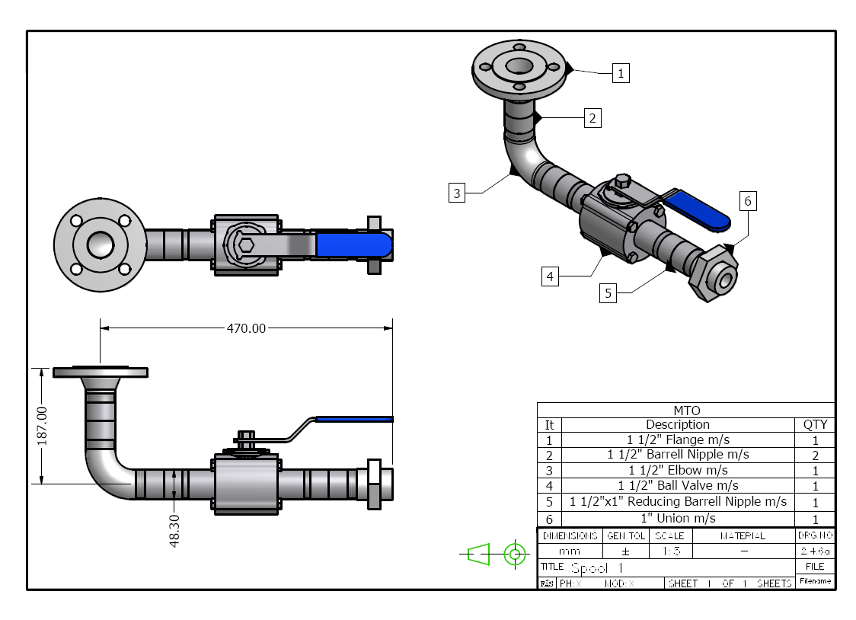
Piping Isometric with BOM
The second level of totals would be used by the project engineer in charge of the system. He/she can track progress of materials used versus what is allocated to complete the system and to monitor wastage of material or track variations if there is an increase in the scope of work.
The third level of totals would be used by the purchasing department. By combining all systems using the same materials they will have better purchasing power and lower logistics and delivery costs when purchasing in bulk.
Accuracy of the bill of materials is essential for accurate quoting of projects which in turn ensures a higher chance of winning profitable work as all costs are derived and built up from the information contained in the bill of materials.

2.0 Information Recorded on the Bill of Materials

Key Learning Points
- Identify the key elements of information for a Bill of Materials
- Identify why this information is critical
- Describe automated systems for generating bills of materials.

2.1 Elements of a Bill of Material
While different industries and companies have different formats and information on their bill of materials the following elements should be included in all bills of materials:
- Customer name
- Project description
- Company Job Number
- Person who prepared the BOM
- Drawing number
- Revision number and date
- Component description
- Component specification
- Material Size
- Material Quantity
An example of a typical bill of materials is given on the next page.

2.2 Purpose of the Elements
The information recorded on a Bill of Materials is used to provide traceability and accountability for companies:
Customer Name: Often used as the first method of dividing and filing information.
Project description: Is used to sub-divide and file individual projects for one specific client.
Company Job Number: This is used to track cost elements in a project and is assigned to materials and labour so the all costs can be tracked.
Prepared by: This identifies who prepared the bill of materials and ensures accountability for it’s accuracy. In large organizations it also allows for someone to query information given in the BOM after it has been issued to site.
Drawing number, revision and date: This ensures traceability and is used to ensure that the most up to date information is being used.
Component description: Basic description of the component required, e.g. Pipe, elbow, flange etc..
Component specification: This gives detailed information on the material to be used. This information is used by the draughtsman to complete the drawing, the purchasing personnel to order the material and the pipe fitter to verify that he/she has received the correct material. This reference will call up a piping specification which will give detailed information on how the pipe line should be installed, supported, inspected, tested and much more.
Material Size: Indicates the size of the components required.
Material Quantity: Indicated the quantity of the components required.
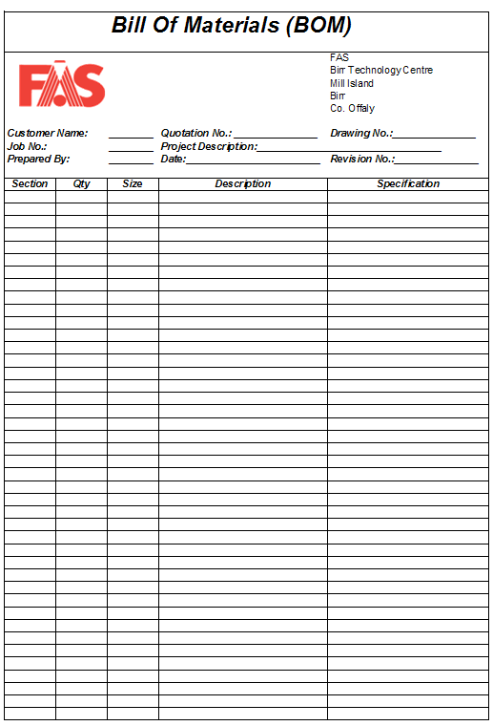
Typical Bill of Materials

2.3 Automated Bill of Material Systems
Sophisticated CAD systems can extrapolate and export actual quantities of materials and components required to complete the system direct from the CAD drawing. This information can be exported as a simple excel list for manual use or as a database file which can imported into MRP or ERP systems for material ordering, order processing, material traceability, costings and resource planning.

3.0 Completing a Bill of Materials

Key Learning Points
- Identify the drawings required and a blank BOM sheet
- Identify the different types of materials used to complete the project
- Identify the need for a separate BOM for each different type of material
- Quantify the materials required and fill out the BOM correctly/

3.1 Filling Out a Bill of Materials
When completing a bill of materials it is important to follow the following guidelines:
- Record information in the header section
- Complete a separate BOM sheet for each drawing of the assembly
- Quantify and record the number of components in each drawing
- Identify the correct size of each component
- Identify the correct description and specification for each component
- All sections filled out with the relevant information
- Separate BOM completed for each drawing or material type
- Components quantified correctly
- Size of components recorded correctly
- Description and specification of components recorded correctly
- Sheet kept clean and presentable
- All writing neat and legible

Exercises
- Identify 3 people who would use a bill of materials and why.
- Complete exercise 2.3.3 which requires the bill of materials for the drawings 2.4.6 a to d to be completed.
- Explain why the accuracy of the bill of materials is so important to the successful running of a pipefitting company.

Additional Resources
- Nayyar, P.E., Mohinder L. (2000). "A1". in Mohinder L. Nayyar, P.E.. Piping Handbook (7th ed.). New York: McGraw-Hill. ISBN 0-07-047106-1.
- David L. Goetsch (2000). Technical Drawing (5th ed.). Thompson Delmar Learning ISBN: 1-4018-5760-4
- International standard ISO 7-1: Pipe threads where pressure-tight joints are made on the threads — Part 1: Dimensions, tolerances and designation. International Organization for Standardization, Geneva.
- BS EN 10226: Pipe threads where pressure tight joints are made on the threads. (The European version of ISO 7.)
- Part 1: Taper external threads and parallel internal threads — Dimensions, tolerances and designation.
- Part 2: Taper external threads and taper internal threads — Dimensions, tolerances and designation.
- BS 21: Pipe threads for tubes and fittings where pressure-tight joints are made on the threads (metric dimensions). British Standards Institution, 1985. (Superseded by BS EN 10226:2004).
- International standard ISO 228-1: Pipe threads where pressure-tight joints are not made on the threads — Part 1: Dimensions, tolerances and designation.
- BS 2779: Specification for pipe threads for tubes and fittings where pressure-tight joints are not made on the threads (metric dimensions), 1986.
- BS EN 10226-1:2004
- ASME B31.9 Building Services Piping; 937 – Leak Testing, 1996 Edition
- Elements of Plumbing by Samuel Edward Dibble, 2010

Castleforbes House
Castleforbes Road
Dublin 1

